PIMMS Experimental Design
Skyline Side
Select 3 method blanks
Select 6 experimental samples that are known to contain PFAS
Create an excel document of the detection frequency for each sample post blank subtraction (mean + 3 s.d.)
Experimental Notes:
- Baker Lab Skyline template imported for the 16.5-minute Reversed Phase method
- Any peak with a >10 ppm absolute mass error is removed
- Any peak with a <1000 peak area removed
- Document has any analyte that does not
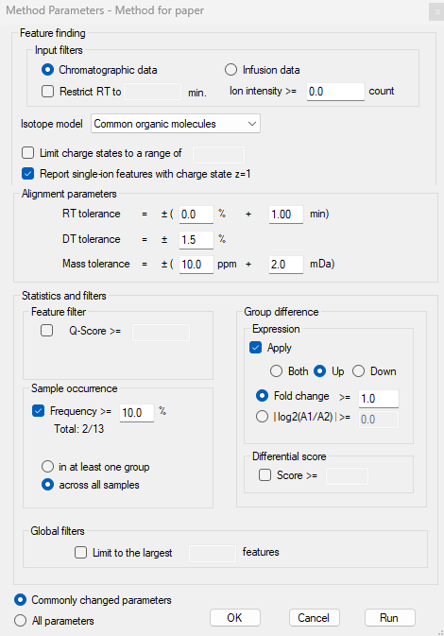
Browser Parameters:

PIMMS Side
Identify all the PFAS that are found in the Skyline in mass profiler
Process the PFAS through PIMMS taking a reading at every stage to determine loss
Determine false positive and false negative rate throughout the experiment

